Meet F9XR's SEO CodeBase Auditor SKILL: Let Your AI Agent Run Your SEO Audit
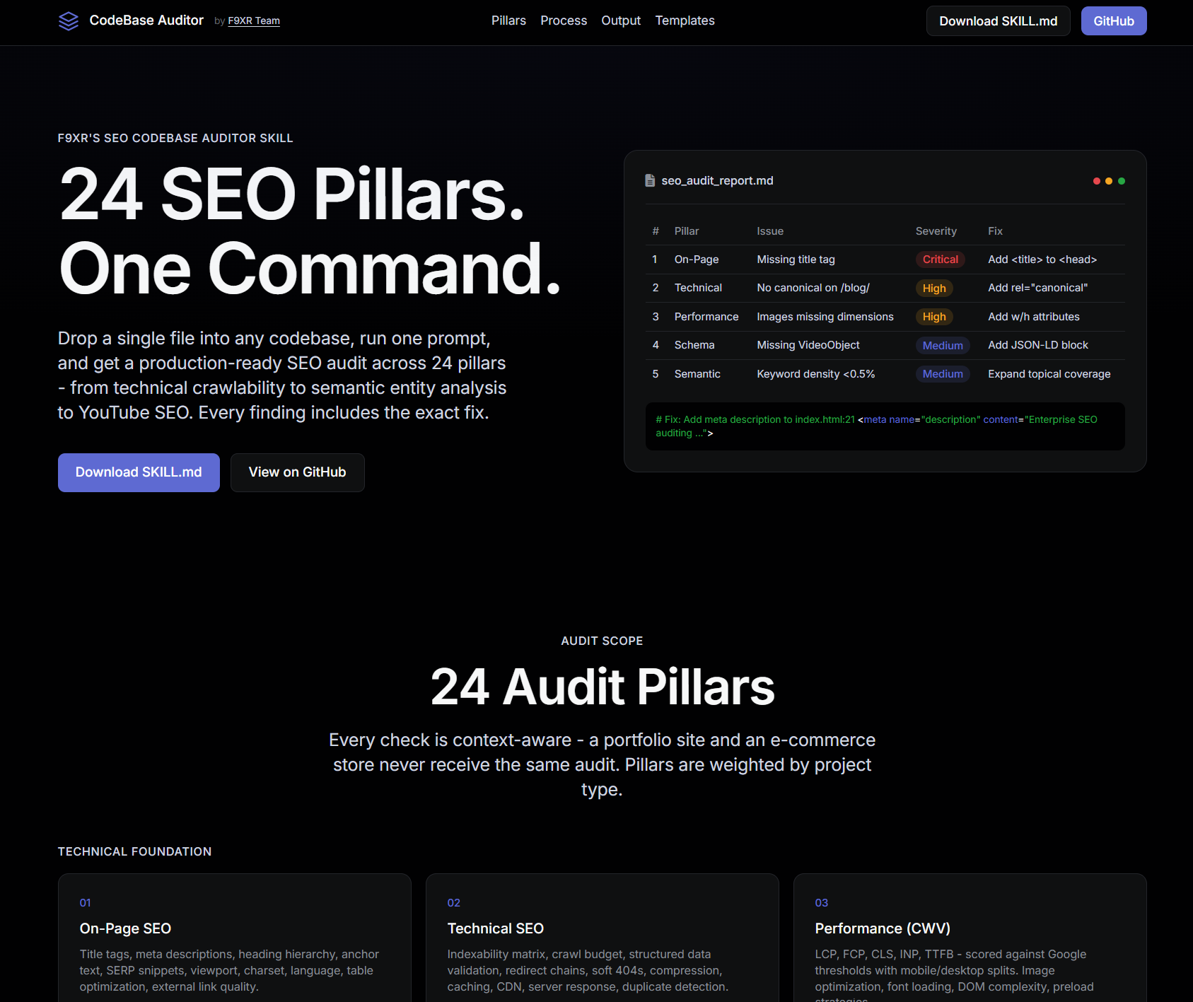

If you run a small business website, you already know the drill. You hire a developer, launch the site, and then months later someone tells you it's "not ranking." You Google "why is my website not showing up on Google" at 11pm, land on three different SEO tools, get three different scores, and still have no idea what to actually fix in your code.
That gap between "here's a problem" and "here's the fixed code" is exactly what most SEO tools never close. They hand you a dashboard full of red and yellow warnings and leave the fixing part to you, or to an agency invoice.
F9XR's SEO CodeBase Auditor SKILL was built to close that gap. It's a single file you drop into your project, run with one prompt inside your AI coding tool, and it hands back a full audit report with the exact code changes needed, not just a list of complaints.
This article walks through what it does, how it works, who it's for, and why business owners and developers are starting to use it as a standard step before every launch.

What is the SEO CodeBase Auditor SKILL?
It's a SKILL file, essentially a structured prompt and rulebook, made by Anjani Kumar Mishra, that you load into an AI coding assistant like Cursor, GitHub Copilot, or Claude. Once loaded, you tell it to run a comprehensive SEO audit, and it analyzes your actual source code against 24 SEO pillars, from meta tags and heading structure to Core Web Vitals and structured data.
The output is two files: a Markdown report (seo_audit_report.md) with a full breakdown, and a CSV file (seo_audit_report.csv) you can drop straight into a spreadsheet for tracking. No account, no dashboard login, no monthly subscription just to see your own site's issues.
This matters because most SEO auditing happens after the fact, run against a live URL by a crawler that can only see what's rendered in the browser. This SKILL audits the source itself, which means it catches structural and code-level issues before they ever go live, and it understands framework-specific quirks that a generic crawler tool would miss entirely.

Why Codebase-Level SEO Audits Matter for Small Businesses
A lot of local business owners assume SEO is something you do after the website is built, a separate project with a separate invoice. In reality, a large share of ranking problems are baked into the code from day one: missing alt text, duplicate title tags across pages, no structured data for the business address, slow-loading images, broken canonical tags.
According to industry analysis from Google's own Search Central documentation, technical issues like poor crawlability and slow Core Web Vitals scores directly affect how pages are indexed and ranked, meaning these aren't cosmetic problems, they're the foundation everything else sits on.
For a local bakery, a landscaping company, or a boutique law firm, this translates into real dollars. If Google can't confirm your business's name, address, and phone number consistently across your site (NAP consistency), or your site doesn't have LocalBusiness schema, you're competing for local pack visibility with one hand tied behind your back.

The 24 SEO Pillars, Explained Simply
The SKILL doesn't run a generic checklist. It organizes findings into four groups, and it's context-aware, meaning a portfolio site and an online store get entirely different audits.

Technical Foundation
This covers the plumbing of your site: on-page basics like title tags and heading hierarchy, technical SEO like structured data and redirect chains, Core Web Vitals performance, URL architecture, mobile responsiveness, image optimization, and sitemap/robots.txt setup including IndexNow protocol support for faster indexing.

Content & Authority
This group looks at whether your content actually answers what people are searching for. It covers semantic SEO and entity analysis, internal linking and link equity, blog and article schema, E-E-A-T signals (Experience, Expertise, Authoritativeness, Trustworthiness), rich results eligibility, and readiness for AI-driven search experiences like Google's AI Overviews and voice search.

Platform & Process
Here the audit adapts to your tech stack: e-commerce specific checks like Product and Review schema, JavaScript framework SEO for Next.js, Nuxt, or Astro projects, CI/CD automation recommendations, migration SEO for domain or platform changes, content pruning strategy, and third-party script audits for performance bloat.

Specialized Checks
The final group rounds things out with social and regional SEO (Open Graph tags, hreflang, local schema), security SEO (HTTPS, mixed content), accessibility SEO, competitor analysis, and video/YouTube SEO including VideoObject schema.

Quick Reference: What Gets Audited
Pillar Group Example Checks Best For Technical Foundation Title tags, Core Web Vitals, sitemap, mobile SEO Every website Content & Authority E-E-A-T, internal linking, AI/voice search readiness Blogs, service businesses Platform & Process JS framework SEO, e-commerce schema, CI/CD hooks SaaS, online stores, agencies Specialized Local schema, accessibility, competitor gap analysis Local businesses, multi-location brands

How the Audit Actually Runs: The Five-Pass Workflow
One detail that sets this SKILL apart from a lot of AI prompts is that it doesn't try to do everything in one pass. It works in five distinct stages, and each one has a specific job.

1. Discover
The AI agent first maps your entire file tree, scans configuration files, detects your routing framework, and builds an indexability matrix. This is also where orphan pages and unreachable routes get flagged, pages that technically exist but that neither users nor search engines can easily find.

2. Analyze
Every file is evaluated against the pillars that actually apply to it. If you're running a static HTML site, JavaScript Framework SEO checks are suppressed. If you don't have a blog, Blog SEO checks don't run. This context suppression is what keeps the report relevant instead of bloated with irrelevant noise.

3. Prioritize
Findings are sorted by severity, then by estimated traffic impact. The Priority Fix Matrix is deliberately capped at 20 items, because past that point, more findings just become noise that distracts from the issues actually worth fixing first.

4. Report
This is where seo_audit_report.md gets generated, following a fixed structure: an executive summary, the priority matrix, and then granular pillar-by-pillar evaluations that show the current code next to the exact fix.

5. Critique
Before anything is delivered, the AI reviews its own findings as if it were a competitor's SEO lead trying to poke holes in the report. Every severity label and root cause has to be defensible, and at least one weaker finding gets removed before the final report ships.
This five-pass structure is really what separates it from a one-shot "audit my site" prompt. Most AI-generated audits either hallucinate issues or bury real problems under generic advice. Forcing a self-critique pass before delivery is a small design choice that has an outsized effect on report quality.

What Makes the Output Different: Fix Blocks
Most SEO tools tell you what's wrong. This one tells you what's wrong and gives you the corrected code block to paste in.
For example, instead of "Alt text missing on 12 images," the report shows the actual <img> tag from your code and the corrected version with descriptive, keyword-relevant alt text already written in. Instead of "No LocalBusiness schema detected," you get the JSON-LD block ready to drop into your <head>.
This "fix is the deliverable" philosophy comes directly from how the SKILL is designed. Every finding has to cite a specific Google guideline, ranking factor, or schema.org specification, if the rule can't be cited, the issue doesn't make it into the report. That evidence-based approach avoids the common trap of AI tools flagging things that sound like problems but aren't actually backed by anything.

Built-In Support for AI Search, Not Just Google
Search behavior has shifted. People are asking ChatGPT, Gemini, Claude, and Perplexity questions that used to go straight to Google, and these AI systems pull answers from structured, well-organized web content. Pillar 18 in the audit specifically covers AI Overview extraction readiness, conversational keyword coverage, featured snippet targeting, and plain-language scoring, all of which matter for showing up inside an AI-generated answer, not just a traditional blue link. You can also read: Is Your Site Agent-Ready? How Cloudflare's Free Tool Can Help You to Stay Ahead of the AI Web.
This is a meaningful shift in how SEO audits need to work going forward. A site can be technically perfect for Googlebot and still be invisible to an AI answer engine if its content isn't structured as clear, extractable passages with direct answers near the top.

Who Should Actually Use This
- Developers and agencies who want a repeatable, defensible pre-launch SEO checklist instead of relying on memory or a generic Lighthouse score.
- Startup founders shipping fast who need a way to catch SEO debt before it compounds across dozens of pages.
- Local business owners working with a developer who want an independent, code-level check that their site is actually built to rank locally.
- E-commerce store owners who need Product schema, review markup, and category page structure validated at scale.

Actionable Tips Before You Run Your First Audit
- Run it before launch, not after. Catching a missing canonical tag pre-launch takes two minutes. Catching it six months post-launch after duplicate content has been indexed takes a lot longer to unwind.
- Don't fix everything at once. Work through the Priority Fix Matrix in order. The top 5 items usually carry the most ranking impact.
- Re-run it after major changes. A new page type, a CMS migration, or a redesign can quietly reintroduce issues that were already fixed.
- Pair it with the CSV export. Assign each row to a team member or track it in your project management tool so nothing falls through the cracks.
- Treat the fix blocks as a starting point, not a final answer. Always sanity-check generated code against your specific templating setup before deploying.

Key Takeaways
- The SEO CodeBase Auditor SKILL audits your actual source code across 24 SEO pillars, not just a live URL crawl.
- It's context-aware, adjusting checks based on whether you're running a portfolio site, blog, or e-commerce store.
- The five-pass workflow (Discover, Analyze, Prioritize, Report, Critique) is designed to produce defensible, prioritized findings instead of generic noise.
- Every finding includes an exact fix block, code you can copy and deploy, not just a diagnosis.
- Pillar 18 specifically prepares your site for AI search engines like ChatGPT, Gemini, and Perplexity, not just traditional Google rankings.
- Output includes both a Markdown report and a CSV file for easy tracking.

Frequently Asked Questions
What is the SEO CodeBase Auditor SKILL?
It's an AI-agent SKILL file that audits your website's source code against 24 SEO pillars and generates a report with exact code fixes for each issue found.
Which AI tools work with this SKILL?
It's designed to run inside AI coding assistants such as Cursor, GitHub Copilot, and Claude. You load the SKILL file into your project and run it with a single prompt.
Does it work for e-commerce sites?
Yes. The audit is context-aware and applies e-commerce specific checks like Product and Review schema, category page structure, and faceted navigation when it detects an online store.
Is this different from tools like Google Search Console?
Yes. Search Console reports on how Google already sees your live site. This SKILL audits your source code directly, catching issues before or independent of a live crawl, and it provides ready-to-use code fixes rather than raw metrics.
Do I need coding experience to use it?
Basic familiarity with your project's codebase helps, since the tool works inside a developer environment. Business owners typically run it alongside their developer or technical partner.
How long does an audit take to run?
This depends on the size of the codebase, but the five-pass structure is built to run in a single session and produce both the Markdown and CSV reports together.

Conclusion
SEO used to mean guessing at meta tags and hoping a plugin caught the rest. Tools like F9XR's SEO CodeBase Auditor SKILL represent where this is heading: audits that live inside your actual codebase, run by the AI agents developers already use every day, producing fixes instead of just findings.
If you'd rather have this handled for you end to end, from the audit itself to the redesign, local SEO strategy, and ongoing digital presence work, the F9XR Team builds and maintains websites with exactly this kind of technical rigor baked in from the start.

